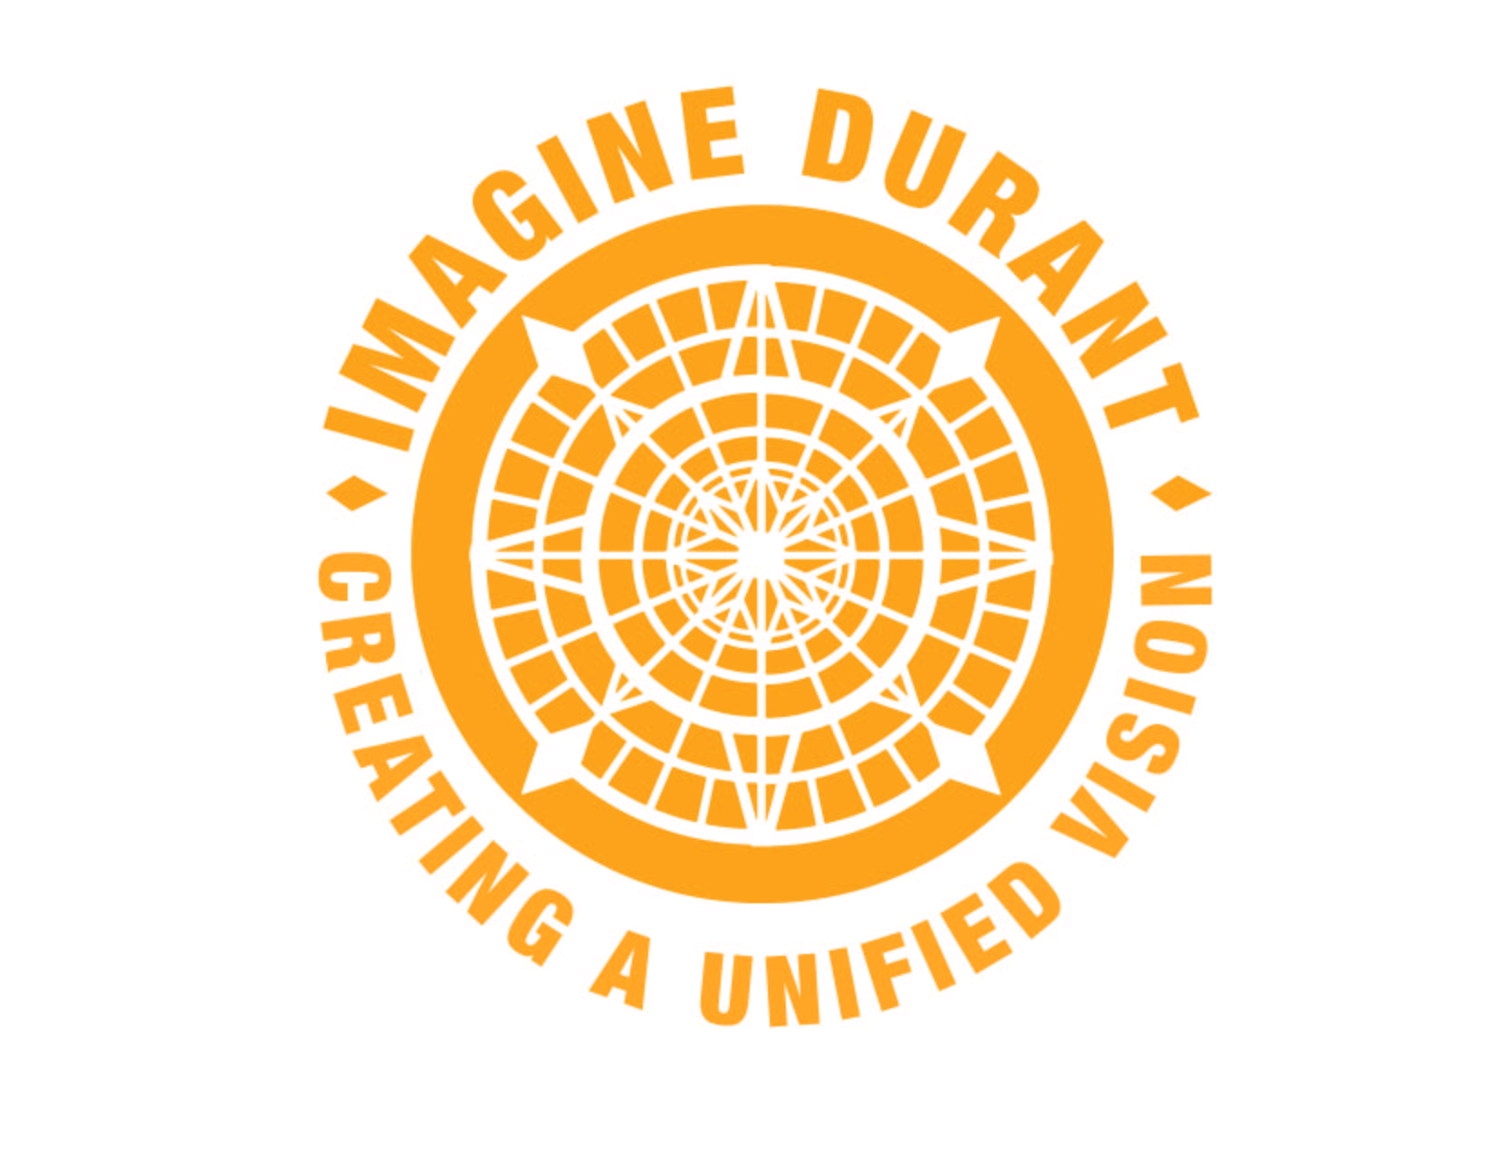

Imagine Durant:

THOUGHT LEADERS Dialogue

Harvest Report

Sarah Pate
Harvest Reporter

Feb. 19-20, 2016

Imagine Durant Thought Leaders Dialogue Participants

Citizens
Melissa Perrin, First United Bank
April Lehrling, SOSU Student Wellness
Rob Piearcy, Runner
Tim Boatmun, SOSU/Walking Trail Committee
Brett Rogers, Runner
Monica Woodall, Physician

Business
Tim Noahubi, Choctaw Nation Environmental Health
Chance Adams, Choctaw Nation Wellness
Tracy Horst, Choctaw Nation Recycling
Mike Simulescu, Physician
Greg Massey, First United Bank

Civil Society
Karla Davison, Mental Health Services
Jona Tucker, Nature Conservancy
Jerry Speck, Turning Point Coalition Representative
Brandi Maness, Bryan County Health Department
Dena Sherrill, Colton’s Run
Kara Hendrickson, Imagine Durant

Civic Managers
Sarah Sherrer, City Manager
Julie Montgomery, Health Department Administrator
Todd Hallmark, Choctaw Nation FACHE
JJ Wilson, Retired Military
Kin Whittington, OBGYN
Chief Gary Batton, Choctaw Nation

Integral City Team
Marilyn Hamilton, Ph.D., Team Leader
David Jaber, Director of Audits & Performance
Scott Moore, Principal Community Builder
Sarah Pate, Scribe

Day 1: Imagine Durant Convenes a Dialogue

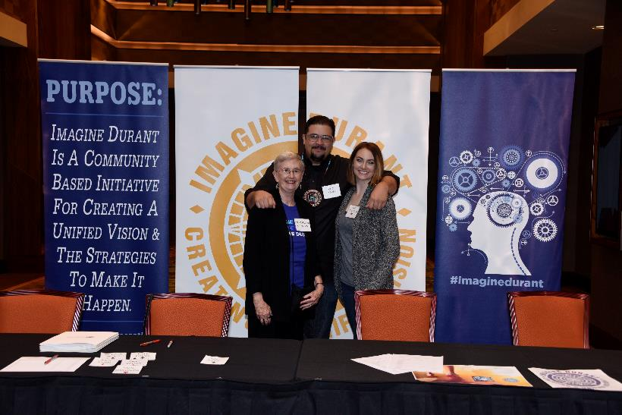

Imagine Durant, a community-based initiative for creating a unified vision and the strategies to implement it, convened a dialogue for local Thought Leaders on Feb. 19-20, 2016. Along with Marilyn Hamilton, Ph.D., and her team from Integral City, the dialogue set out to evaluate the current state of Durant’s Health and Environment. Participants came from the four voices of the city – Citizens, Business, Civil Society and Civic Managers – and were taken through a series of exercises in order to gather ideas for improving the Health and Environment of the community moving forward.

The group gathered together Friday evening over a meal in one of the new meeting rooms at the Choctaw Casino Resort. Chief Gary Batton welcomed everyone by saying “Halito” meaning hello in Choctaw. He reflected on a time almost 20 years ago when the Choctaw Nation could barely meet payroll; fast forward to the facilities and programs the Choctaw Nation are able to offer today:

“We are building the future of Durant. That’s why we’re asking all of you to be involved. Where do we really want Durant to be, and how do we get there?”
Chief Gary Batton

Imagine Durant began two years ago as the result of a conversation over lunch between Chief Batton and Greg Massey, CEO, First United Bank.

“Over the next year we should have a holistic map and strategy of where to take this community. It’s inspiring to me the number of different people from all over the community coming in to volunteer. Marilyn always says, ‘the right people will always show up,’ and they do.”
Greg Massey

The intentions of the Imagine Durant Dialogue series are to:

- Create interpersonal connections across the diversities of the city – age, gender, students, workers, employers, ethnicity, race, etc.
- Create connections between people’s perspectives of the city’s potential
- Discover common ground to build on and respect differences that make a difference
- Imagine how we can improve the quality of Durant’s wellbeing in a way that is supportive of all over the next 30 years and find next steps to make that possible

We Tell Stories of Health and the Environment

After dinner, participants were asked to share a brief story about a specific time when they experienced the true meaning of a healthy environment or a healthy community.

Many stories revolved around being outside and immersed in nature, a time when that was more common and a desire for that mindset in our current culture.

Tracy Horst, Choctaw Nation Recycling, recalled a time when she visited Yellowstone National Park with her family. She told the group of the cabins they stayed in with no televisions – just a bed, a basic bathroom and one small mirror.

“Everyone is outside interacting. The kids are playing. Everything is clean and neat. Everyone is happy, and it just falls into place.”

Tracy Horst

Echoed throughout the room was the challenge of getting families and kids outside despite the temptation of distractions such as television, video games, cell phones and other electronic devices.

Todd Hallmark feels a responsibility to promote health and wellness as a physical therapist. He is constantly pushing his kids to get up and go outside with him to play basketball, baseball or ride their bikes, even when he is tired after a long day at work. He feels this effort is paying off as he sees his kids begin to make healthier choices on their own.

“Even if you feel like you’re not making progress, it’s important to keep trying.”
Todd Hallmark

A concern for Dr. Monica Woodall, Primary Care Physician, is the level of access for the impoverished in Durant who would like to be healthy, but cannot afford it.

“Durant is actually really fit. We have a lot of fitness centers. We have the Oklahoma Healthy Aging Act. But these things target specific people. They are already fit, have money or are over age 55.”

Dr. Monica Woodall

Woodall went on to discuss a time in her life when she was the healthiest and attributed it to the fact that it was so easy and didn’t cost her any money.

Chance Adams, Choctaw Nation Wellness Center, agreed that we need to empower citizens to take charge of their health.

“To me, the magic happens when ability intersects with empowerment. Ability equals skill. Empowerment equals the community, employers, and schools giving people permission to utilize their ability.”
Chance Adams

Tim Boatman, SOSU, expressed a time when he felt a sense of health and wellness when he attended a camp for troubled kids with a young man he was mentoring through Bryan County Youth Services.

During their time at camp, they ate three healthy meals a day, stretched, exercised, laughed and played. There were no televisions, and they spent a lot of time outdoors.

He saw no behavioral issues that had to be addressed with his fellow campers in his four years of attending this camp.

“Why did this camp work? We were taking care of ourselves physically, emotionally, spiritually, etc. As a result, we were more productive, healthy and happy.”
Tim Boatmun

Several in the room remembered a time when an entire community came together in support of a cause. Dena Sherrill spoke of Colton’s Run, an event born out of tragedy (the unexpected death of her son) that has continued to grow and bring the community together in the spirit of health over the years.

“The first year we had 400 people run in Colton’s Run. Last year we had 1300 runners. It’s been neat to see people who walked the Fun Run the first year and now run a 10K. We also have people begging for a half marathon. We knew this was a great community, but the way people come together for you when you go through something like we did is pretty amazing.”
Dena Sherrill

Jona Tucker, Nature Conservancy, reminisced about being part of a community growing up in a small town. She believes community is about people and people caring about people.

“We create community wherever we go. It helps if you have a shared purpose, you feel like you are needed and you are accountable.”
Jona Tucker

Day 2: A New Story Emerges

Participants were seated in a circle as they gathered together on day two to collect ideas for improving the health and environment of the community of Durant.

The intention of the circle was to remind everyone of the unity needed for a successful dialogue. Those present were encouraged to be open and share, while also being aware of their role and responsibility to the community and each other.

Guidelines were shared for a generative dialogue:

- Listen compassionately
- Honor and respect each other’s contributions
- Speak from your own experience
- Avoid criticism and persuasion and agree to disagree
- Be aware of how often and how long you speak
- Seek to understand and learn
- Make sure everyone has a chance to speak

An Interactive Panel: Community Health Scan, Environmental Scan and Future Trends

The day began with five professionals shared their expertise about the health and the environment: Jerry Speck, David Jaber, Tim Noahubi, Tim Boatman and Jona Tucker.

Jerry Speck, Mobilizing for Action through Planning and Partnerships (MAPP)

MAPP is a community-driven strategic planning tool for improving community health. Facilitated by public health leaders, this tool helps communities apply strategic thinking to prioritize public health issues and identify resources to address them. Durant’s last assessment placed it 46th in a field of 77Oklahoma counties. The MAPP process is designed to make citizens aware of health indicator ratings and prioritize actions to improve them. MAPP is currently being implemented in Durant during 2016 and 2017. Imagine Durant is working together with MAPP to ensure wide participation.
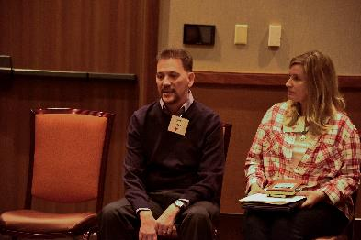
The four MAPP assessments for Durant include:

- Community themes and strengths assessment
- Local public health system assessment
- Community health status assessment
- Forces of change assessment

David Jaber, The Natural Step

The Natural Step framework helps cities to systematically enhance the sustainability of their operations and facilities. It looks at the health of the Earth’s living systems from a broader perspective and examines what we need to do as a human society in order to survive and thrive into the future.

According to Jaber, we are seeing a decline in resources and an increase for demand of resources globally. He believes we need to level these off for sustainability and that this is something to think about as Durant considers its future.

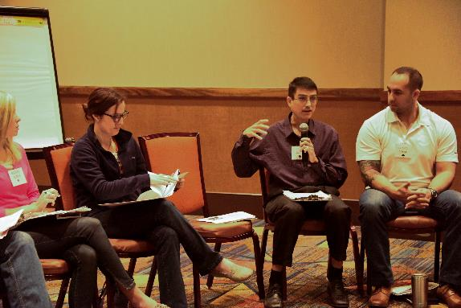

Tim Noahubi, Choctaw Nation Office of Environmental Health

The Choctaw Nation Office of Environmental Health is presently engaged in a program to provide sanitation facilities, which include water and wastewater facilities.

Funding for this program is provided through the U.S. Indian Health Service; therefore, their qualification guidelines are utilized. The funds are used for items such as water wells, septic tanks, drain fields, community water connections and community sewer connections.
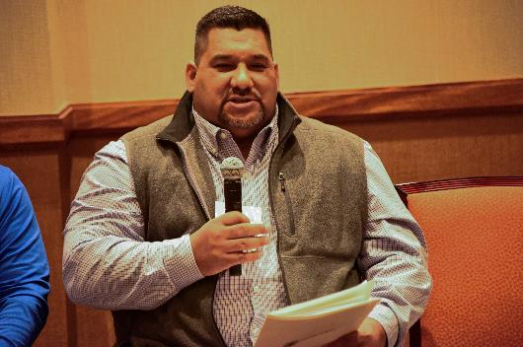
Noahubi says there are many rural water companies that can’t maintain their systems or repair leaks on their own. The tribe is able to help get funding from the federal government to help with those situations. They are also able to provide services for individual homes of tribal members and currently serve about 100 sites per month.

Tim Boatmun, Nowa Oka Walking Trail

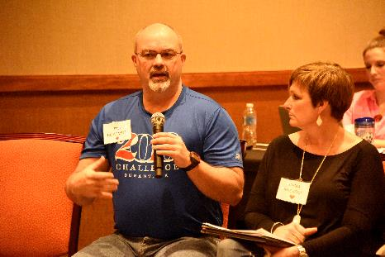
The Walking Trail Project was born out of the first series of dialogues held by Imagine Durant. Since the idea originated, a committee was formed to identify who is doing different things around town and how to pull all of it together in order to create a link between the economy, community, health and environment. There are circles and routes around town that have naturally developed, but there is not a well-thought-out plan for how to integrate the paths already in place.

The committee’s vision is to create one safe, unobstructed trail that connects Downtown Durant to Carl Albert Park to Southeastern Oklahoma State University to Rocket Park to the current Choctaw Nation Headquarters with hopes of eventually expanding it even further.

Jona Tucker, Nature Conservancy

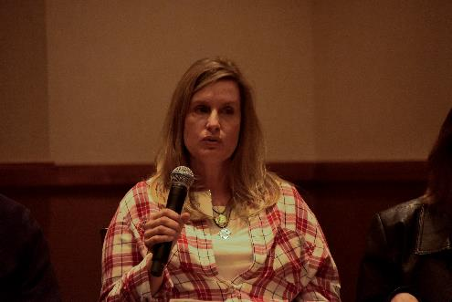
The Nature Conservancy is a non-profit organization with a mission to conserve the lands and waters upon which all life depends.

According to Tucker, 95 percent of Oklahoma’s land is privately owned, which contributes to the fact that we do not have a culture of going outside – there are simply not a lot of public lands.

Durant’s own water supply comes from Lake Durant and the Blue River, which is surrounded by private land. The Blue River is one of the last two free-flowing streams in Oklahoma. It originates in southeastern Murray County, flows east into Pontotoc County, turns southeast through Johnston and Bryan Counties and joins the Red River in southeastern Bryan County.

Four landowners control the Blue River and three of them are Texans who bought the land as an investment. The Nature Conservancy is looking to buy the land that surrounds the Blue River in order to manage the native plant community appropriately, so that it is healthy and vibrant.

Tucker encourages the City of Durant to look to its own natural beauty and work to sustain what is already there in addition to looking for new resources.

Small Group Dialogue: Current State and Imagined Futures for the Health and Environment of Durant

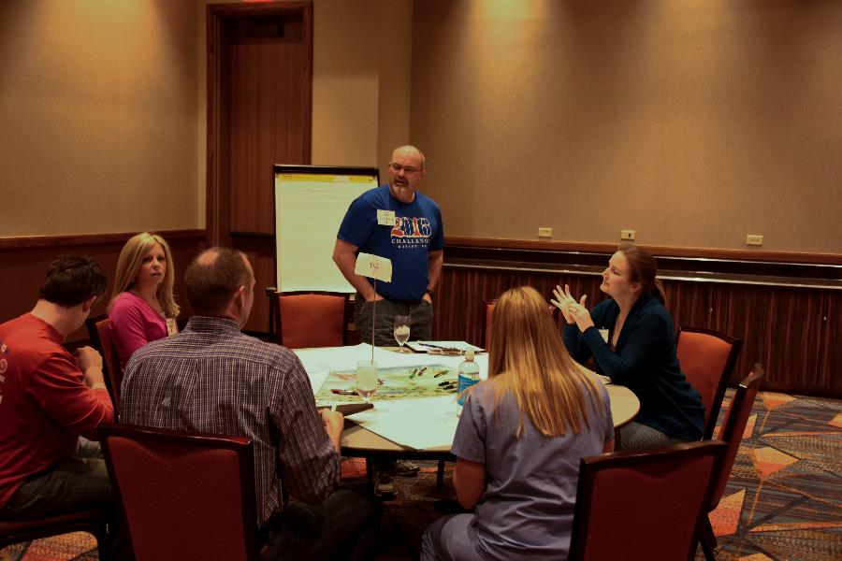
Current Health and Environment
As participants rotated through a series of small groups, they focused their attention on assessing the current state of Durant’s health and environment, as well as what it might look like to have a resilient community 30 years down the line.

Many positive attributes came out of these discussions, some of which may lead to opportunities for improvement.
It was noted that Durant has a “small-town feel,” which contributes to a sense of wholeness, belonging and well-being. This leads to an increased desire to raise children in Durant, highlighting a need for family friendly events and opportunities to get outdoors and connect with the community.

Another positive aspect noted more than once was the increased involvement of the Choctaw Nation with the community as a whole, although not everyone in the community has access to all of the programs and facilities offered by the Choctaw Nation.

Other facets named in relation to the current health and environment of Durant, as well as needs that arose include:

HEALTH ASSETS
- Colton’s Run
- Fitness Centers
- Sports Complex
- Boys & Girls Club
- Free medical clinics
- Women’s Center
- Local hospital
- Easy access to health care
- Large faith-based community

ENVIRONMENTAL ASSETS
- Civic passion
- New leaders open to new ideas
- More collaboration in the community
- Rich arts community with intention to build Downtown
- Southeastern State Oklahoma University (brings diversity and population, but missing the college town atmosphere)
- Natural beauty and trees
- Parks
- Lake Durant (improve camping, trails, fishing and picnic areas)
- Lake Texoma (boating, fishing, hiking)
- Blue River
- Recycling Center
- Annual city clean-up

HEALTH AND ENVIRONMENT NEEDS
- Better communication/advertisement of available programs
- Healthy food options at a reasonable cost
- More health care providers
- Understanding of mental health
- Upkeep of older parts of town that are currently in neglect
- Shelter for men
- Participation in the MAPP assessment and follow-up process

“Meeting basic needs allows for people to be or make themselves healthy.”

Julie Montgomery, Health Department

Future of Durant+30
When imagining the future of Durant 30 years from now, many envisioned:

A VIBRANT DOWNTOWN
- Pedestrian access
- Active night life
- Healthy eating choices
- Farmer’s Market/Community garden

A TOURIST DESTINATION
- Town connected to Lake Texoma
- Developed Highway 70 corridor
- Economic development around Lake Texoma
- Recreation on and around Lake Texoma
- A town connected to the Choctaw gaming tourism in a healthy way

EASY CHOICES FOR HEALTH
- Established, well-maintained walking trail with a sense of security
- Adult sports leagues
- Large recreational center
- Public swimming pool for adults
- Healthy infrastructure, allowing for a car-free lifestyle (sidewalks)
- A more accessible recycling program

A “FRONT PORCH” COMMUNITY

“We have to get people back to the front porch versus only seeing them at the front door.”
Tracy Horst

- Community pride
- Active retired population
- Connection between all generations
- Integrated population (diversity)

After rotating though four different groups, participants returned to their original group to produce an album with four songs to represent key themes that emerged from the discussions around Durant’s current and future state of health and environment.

Current Health

Now That’s What I Call Durant, Vol. 1
- Downtown (Main Street is a big part of Durant and who we are as a town.)
- Beat It (Health and obesity are big problems here. A lot of people don’t exercise or eat healthy food.)
- Let’s Get Physical (We need to create opportunities for physical activity.)
- For the Love of Money (Bring the cost of medical care down.)

Current Environment

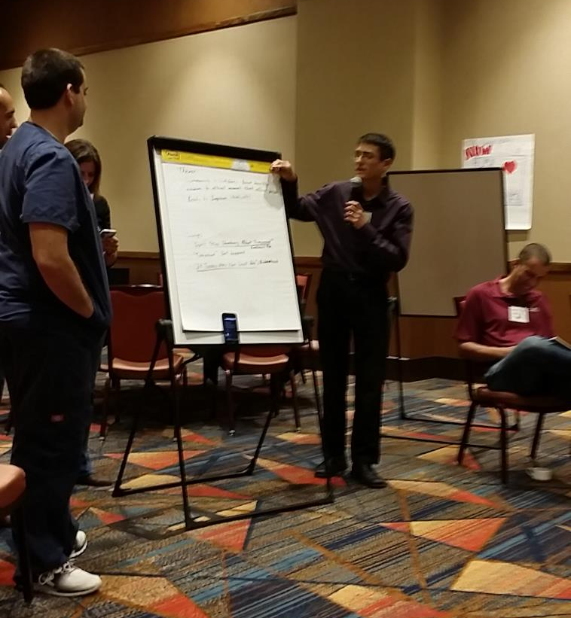
Sense of Community
- Don’t Stop Thinking about Tomorrow (Durant is ready to move forward.)
- Tomorrow
- If Today Was Your Last Day (We need to preserve our current resources.)

Future Health

Routes to Success
- Don’t Stop Believing (Opportunities for health – free clinics, pharmacies, gyms, wellness center)
- Beautiful Day (Vitality – school systems, Choctaw Nation, university)
- We are Family (Unity – being connected in a small town; being a family)
- We are the World (Civic passion)

Future Environment

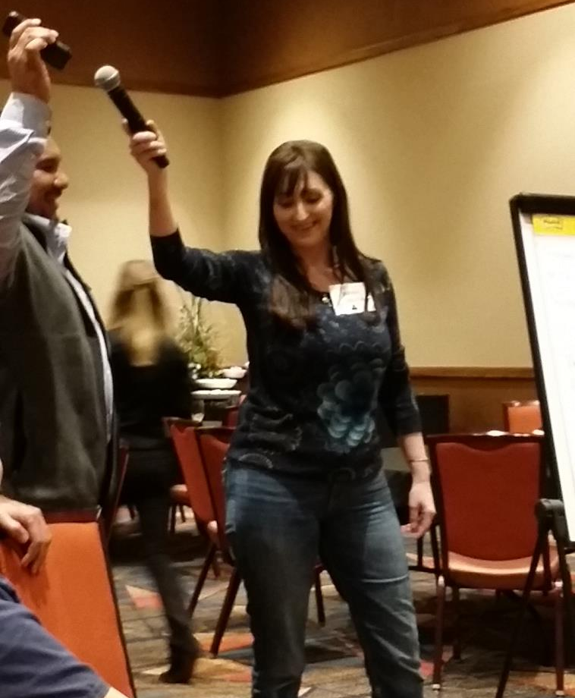
Attitude is Contagious
- Right Now (People are taking responsibility for the community)
- Dream On (Share these attitudes with friends and family)
- What a Wonderful World
- Downtown (Vibrant downtown – a place for people to connect and be together)

Field Trips Feature Signs of Progress and Early Wins

During the afternoon session, participants were asked to consider signs of progress and project future jackpots that may occur from early wins through implementing this process. Each group mapped out a field trip through Durant to illustrate their revelations.

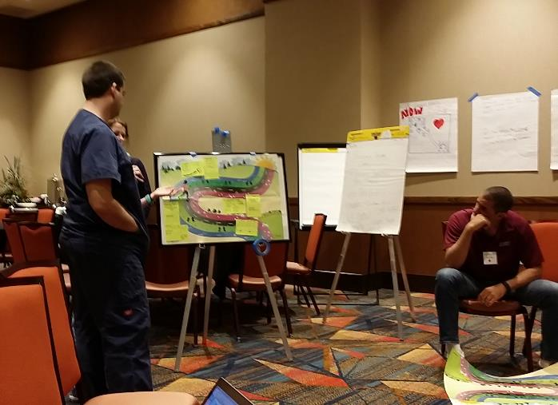

Field Trip #1: Signs of Progress – Durant in 2016

- Imagine Durant helps to create a shared vision
- New leadership in multiple agencies, which drives new vision
- Development of a Community Calendar and Website
- First community trail initiative
- Parks and trails in place with opportunity to connect
- Plans for a community garden
- Farmer’s Market/Farm-to-Home program
- Recycling program exists with opportunities for improvement
- Conservation efforts in place for water supply (Blue River)
- Increase in vaccination rates through collaborations between the Health Department and Choctaw Nation
- RAM clinic coming in May, which meets the needs of those who cannot afford preventative health care
- MAPPs process to be complete in 12-18 months
- Plans for a new clinic within the Choctaw health system

Field Trip # 2: Jackpots from Early Wins – Durant in 2046

- Revitalized Downtown with public restrooms, lawn area, outdoor concerts, family events, pets welcome, food truck alley
- Large Farmer’s Market
- Farm-to-Table restaurants
- Community Center utilized by all generations
- Integrated trail system allowing a way for people young and old to get around the community without a car
- Large, community-based park
- Carl Albert Park and Lake Durant improved with new equipment and tracks
- Colton’s Run is now a Boston-style marathon that takes runners through all the best parts of Durant
- Clean community environment
- Community is educated on the value of recycling and curbside recycling is now available
- Clean water supply
- Economic development around Lake Texoma
- Master-planned housing communities
- Vibrant faith-based community with churches working together to help meet basic needs for citizens
- Updated Boys & Girls Club
- Financial health among the community with a decreased poverty rate
- Increased rate of college graduates in population and investment in the right types of jobs
- New Choctaw medical complex
- Lower hospital admission and readmission rates
- Obesity rates go down
- Increased mental wellness throughout community

Moving to Action

At the end of the day, participants returned to the plenary circle and were asked to think about potential new collaborations that will point Durant in a positive direction.

Participants pointed to these important potential collaborations as keys to moving forward:

- A partnership between the City of Durant and the Choctaw Nation;
- Including the Nature Conservancy in planning for the local water supply ;and
- Including the schools when considering curbside recycling
- Partnering non-profit organizations with the faith community to meet basic needs for the citizens of Durant, especially the homeless or those with a lower level of income.
a partnership between the Choctaw Nation, local physicians and the schools to promote movement and exercise among community children.

The Power of Burning Questions

Although the day closed with positive attitudes and excitement about the future, many were left with burning questions, such as:

- How will we fund all of these ideas and will we have the resources and leadership to maintain what we have done long-term?
- How do we best represent those without a voice in this room and how do we make the community aware of all these efforts?
- Who will help the homeless? Has anyone assessed the costs to police, hospitals, courts, etc., for dealing with the chronically homeless and chronically addicted people, and can we house or help them to reduce costs and make the city safer and provide safety for these people?
- What are the next steps, and how can we keep the momentum up?

Imagine Durant is committed to connecting those with passion to those who can help make change happen. The next dialogue on the Health and Environment of Durant will be open to the public and held on April 23, 2016, at Families Feeding Families from 8 a.m. to noon.

